Why do I need to Skirt my fleece? Skirting removes the undesirable part of the fleece. A fleece will skirt easier right after shearing, the longer it sets the more difficult is it to skirt as the fibers will begin to mesh/felt together. Just remove what you don’t want!
Lay your fleece out on a skirting table, old piece of screen or any flat service. A fleece may contain second cuts (tiny pieces at the end of the cut end of the lock), urine stains, mats, course belly fibers, hay and other vegetable matter. The skirting will produce a cleaner fleece and a more usable end product. A clean fleece will save on shipping and processing costs if you send your fleece to a mill. A fleece you are entering for completion in a fleece show MUST be skirted before entering.
Washing your fleece will remove dirt, body oils and some of the vegetable matter. Carding will align the fibers in the same direction to be made into rovings or batts, but again does not remove the unwanted fiber and vegetable matter.
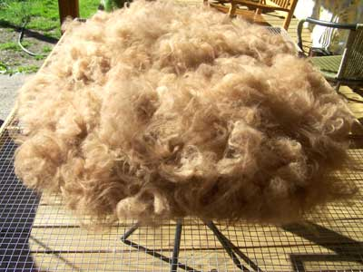 | A beautiful skirted show fleece  Below a skirting table that can be set up on saw horses. Our table is 60 inches by 36 inches. We used ¾ by ½ inch wood and ½ inch square welded mess wire. This works well for the smaller pieces and dirt to fall through. It is portable and easy to store.
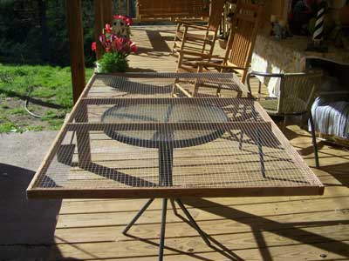 |  | 