Spinning a yarn

October 21, 2004
Volume 1, Issue 7
Special Interest Articles:

• Next meeting is October 25, 2004.

• Project Fiber Arts Support for Soldiers!

• Calendar of events.

• Field trip to the Spinning Turtle
Individual Highlights:
Member Focus 2
Murphy’s Law 3
Classified 4
Spinning Yarn 5
Guild Info 6
Calendar 10

River City Fiber Clan www.goodnewsllamas.com/fiberguild/

Fiber Arts and Caring for Our Soldiers

Scott Newcome, Linda’s son, is about to deploy to Kuwait. The unit has 47 women and 252 men, who will be there for about a year. This is a transportation unit and they will be running missions from Kuwait into Iraq. Some of these soldiers are college age and this is the farthest they have been away from home. Several of these soldiers crochet and cross-stitch.

Linda is spearheading a project of support for the 778th. She wants to have enough Christmas cards for every soldier in the unit. You can address the Card to “Any Soldier, 778th Transportation Unit.” These cards must be received before thanksgiving in order to make it there in time.

Yarn and More will be a collection point for items for the 778th. Non-perishable food items, gum, hard candy, candy canes, travel size toiletries, chapstick, solid sun block, nuts in cans, cards, small games, puzzles, books, stationery, cards, yarn, threads, patterns, etc. Of course cash for buying items or for help with shipping costs will also be much appreciated.

I hope our guild will be able to help out Linda in supporting Scott’s unit. Let’s please remember to hold our soldiers up in our thoughts and prayers. They are fighting for our freedom and safety.

I’d like to encourage each guild member to bring an item or two to the meeting on the 25th. This will be a great start for the 778th.



This issue is dedicated to our brave soldiers.
God Bless and keep you!

MEET NANCY CROCKETT – TEACHER, GRANDMA, SPINNER
Spinning a yarn
Page 2 of 10

Hello, I am Nancy Crockett and here a little about me. I was born in Charleston, WV and then moved to Huntington. I attended Marshall University majoring in Early Childhood education. I got my master’s in Elementary Education.
I really can’t remember when I took an interest in crafting. I have been some form of crafting since I was very young.
Needlework was my first choice of crafting and I still have the first piece I did. Throughout the years I have done knitting, counted cross-stitch, crocheting, embroidery, sewing, quilting, and numerous other crafts. There is such a satisfaction for me to make something I could easily buy, but would rather make myself.
There are many other ways I enjoy spending my time. The love of my life is my two grandchildren. Brett is seven and such a joy to be around. Brianna is three and I call her “my high maintenance girl”. There is never a dull moment around her.
I enjoy doing things outdoors. I bought a kayak about five years ago. I love to take it out on Beech Fork Lake. Its great to live close to a lake.
Photography is another pursuit I enjoy. The digital camera is the way to go. It is great fun to take your pictures and then print them out yourself. And now with grand children I can document everything.
I don’t know when the spinning bug bit me but it has taken me quite a while to act on this wish. My husband offered to buy whatever was necessary to get me started years ago but with family and work, there was never enough time to learn. Then my prayers were answered last march when I went to the WSAZ Home and Garden Show. Over in the corner with some llamas were the nicest lady and her husband, Judy and Tom Ross. I first asked questions about the llamas and then I spied Mitzi at her spinning wheel. I told Judy that I would love to learn how to spin. She told me about a group that was just starting to form. The rest is history! I have a long way to got but I now feel much more comfortable then I did those first few months at the wheel. There are so many things I still want to learn how to do and our little fiber group is helping me do this.
Nancy and her husband, Bruce lives in the Wayne, WV area. Bruce has begun making lovely orifice hooks. If you need an orifice hook for your wheel let Nancy know.

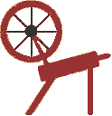
“What is now proved was once only imagined.”

Coming Soon
Spinners Poker – watch for more details

Murphy’s law for fiber arts…

Easy how-to directions for making felt.

1. No matter how carefully you warp a loom, or how simple or complicated the warping,
there will always be one end, which will be sley incorrectly. You will not notice this until
loom is fully warped.

2. If you work in fiber, you will at some point…
  - be asked if its macramé
  - be told its cute
  - be asked if you know their Aunt Clara. She makes cuddly, fuzzy kitties from fake pink fur
  - be asked where you bought the kit
  - be told, “That’s easy, I can do that, too.”

- If you sell your products, you will hear:
  - But there cant be more than $5 worth of products in that
  - Its nice, but does it come in puce
  - Can I clean it in the washing machine
  - I can get the same thing at Wal-Mart for half the price

- All yarn breaks when you cant afford to have it break.

- All looms have one harness that sticks, and all loom benches are a pain in the *** to sit on.

- All how-to instructions leave out one important step.

- All yarn in the color you want is $30 a pound.

- Your best friends will always love your worst pieces.

- Your cat, dog, or child will get into the angora you just paid $8 an ounce for and get it all over the house.

- When you spouse’s boss comes to dinner, she will be allergic to wool.

- When demonstrating, your drive band will break and you wont have an extra one.

- Someone will always accuse you of abusing animals to get the fur or wool.

Reprinted from the Canton Weavers and Spinners Fiber Facts.

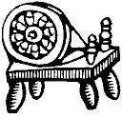

“Life is change. Growth is optional. Choose wisely.”
Karen Kaiser Clark

Spinning a yarn
Page 3 of 10

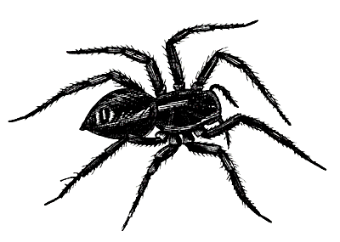

Spinning a yarn
Spinning a yarn

Kevin Rice – kc8kya@yahoo.com
Kevin is medical researcher, educator, and crocheter.

Sandra Rice – sandrajoy@worldnet.att.net
Sandra is a college student, crocheter and a beginning spinner.

Anne Dobbins – annedob@zoominternet.net
Anne is a grandmother, gardens, and knits.

Linda Newton – figsatgrub@earthlink.net
Linda works with a local chiropractor; home schools her 3 children, raises llamas, and is learning to spin.

Heather Newton – figsatgrub@earthlink.net
Heather is a high school student, 4 – Her,
WELCOME NEW MEMBERS

Page 4 of 10

“Everything has its wonders, even darkness and silence, and I learn, whatever state I am in to be content.” Helen Keller

Classified Ads –

Handspinning done with any type of Fiber. Reasonable Rates please contact Chereen Thompson 419-826-5094 or honnaleellamas@hotmail.com

Good News It’s Beans – Llama manure for sale ready for your garden or landscaping project. 30 lb bags $7.00 contact Judy at ross@marshall.edu or 740-867-4267

Llama Rovings for Handspinning available – Llama rovings in 9 different colors available at $3.00 an ounce. Handspun llama yarn available at $4.00 an ounce. Contact Judy at ross@marshall.edu or 740-867-4267

Ohio Floor Loom For Sale - Harrisville 22’, 4 harness, 6 treadle floor loom. Please contact Sandy Ceglarski for more info at sandyc@thirdplanet.net or 419-469-9707.

Do you need to destash and make some room for new stuff? The holidays are coming!!!!

Page 5 of 10
Spinning a yarn
Page 5 of 8

Woolen, Semi-Woolen, Semi-Worsted, Worsted Spinning
By: Rosemary Brock – www.textilelinks.com
In 1987 I took a wonderful 3-day workshop with Patricia Emerick on spinning fine fibers at the Interweave Press SOAR in Winter Park, CO. This was the first year that IWP had Margaret Stove and many people in our class were disgruntled that they weren't next door with Margaret. Except for a few of us. I had attended a seminar with Patricia previously and knew her to be a wonderful spinning teacher. And we had a great time.
Patricia, wisely, was not trying to compete with Margaret. Instead she offered us a different approach to fine spinning. She had six different fibers going from Pollwarth (the coarsest) to the finest (quiviut). Patricia had a variety of tools for us to process the fiber with. Patrick Green's drum carder with the fur cloth, cotton hand cards, dog combs, flicker, true English combs, peasant combs and great little double-row of fixed tines from Tynsel Handspinners. The combs we used in class were the Russian Paddle and English combs made by Mr. Meck (now deceased) in Oregon. Obviously, not all techniques work with all fibers. Trying to comb a short fiber like cashmere simply won't work.
What Patricia had us do was to take each of our fiber sources and divide them in half. Then process each half with a different technique -- using all the fibers and techniques by the time we were done. And I was amazed at the different end results. There is a considerable difference between a worsted-prep, woolen spun and worsted-prep, worsted spun.
Taking the exact same fiber source you can end up with six, very different yarns.
Besides having a lot of fun with Patricia, getting a swell introduction to using wool combs, and playing with some exotic fibers, I also learned a valuable technique. What I learned is that if you have a special fleece, it is well worth the time and effort to try out a variety of techniques to find what will produce the yarn you want. It's a very exciting step when you go from finding a use for the yarn you made to making the yarn you want.
If I have a special fleece, I will try to do just that. I create at least six samples:
- woolen prep+woolen spun = woolen yarn,
- woolen prep+worsted spun = semi-worsted yarn,
- semi-worsted prep+woolen spun = semi-worsted yarn,
- semi-worsted prep+worsted spun = semi-worsted yarn,
- worsted prep+woolen spun = semi-worsted yarn,
- worsted prep+worsted spun = worsted yarn.

Of these, I find the "worsted prep + woolen spun" hardest to spin.

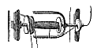

Spinning a yarn
Spinning a yarn

Page 6 of 10

Woolen, Semi-Woolen, Semi-Worsted, Worsted Spinning
By: Rosemary Brock – www.textilelinks.com

So let's define the terms a bit. Woolen prep refers to hand carding the fibers to produce an open, lofty fiber mass with all the fibers going every which way. Semi-worsted prep refers to using some of the various "peasant combs". The ones we used in Patricia's class were the Russian Paddle combs made by Mr. Meck. There are many varieties of peasant combs still available. A few of them are: Valkyrie makes the Valkyrie combs, Indigo Hound makes the Viking Combs, and Louet makes the Dutch Combs. Worsted prep refers to using some variation of the "English combs". It produces a "top" of parallel fibers of an even length. If you become a worsted spinner, you should start saving as these seem to start at ~$200. Peter Teal makes combs that are ~2/3 scale which are quite nice. He finds the weight of the combs more comfortable for most people. Alden Amos makes combs that full sized (for robust combers) that are wonderful. For step-by-step directions on worsted spinning, please get a copy of Hand Woolcombing and Spinning">"Hand Woolcombing and Spinning" by Peter Teal.
Woolen spun refers to a form of spinning that incorporates the maximum amount of air into the yarn, producing a lofty, insulating yarn; great for sweaters. This is probably what most spinners start out doing. A common side effect for new spinners is letting the wheel go too fast for your ability to feed in fiber. The next thing you know, the twist has traveled up through the "drafting triangle" right into the fiber source. This gives you the yarn that moves past the pinched fingers bears a resemblance to the "anaconda that has just swallowed the chicken". More accurately, several chickens. Worsted spun refers to a very controlled form of spinning, where the twist never. The thumb and forefinger are pinched together just before the drafting triangle, and this produces a yarn which is extremely longwearing, and almost cool. This is the yarn that has been traditionally used in men's suits.
For those of you who are fighting with learning worsted spinning, let me suggest that you elevate your right hand. The twist will not go past your hand. An easy demonstration of this is to spin, put a pencil under the yarn feeding into the orifice, and then raise the pencil
above your left hand by ~4 inches. Keep treadling. You can see the twist accumulate to the right of the pencil. Lower the pencil and watch the twist travel up the yarn, into the fiber, and now you have a mess. You can do the same thing with worsted spinning. With your right hand rotated so that the thumb is on top, pinch off the yarn between your thumb and forefinger. Now elevate your hand a few inches. You won't have to fight the twist nearly as much to produce a good worsted yarn.
Article written by Rosemary Brock. For more information and more articles please see www.textilelinks.com

Please remember to exercise your right as American and VOTE on
November 2!!!

You do make a difference and your voice does count!

We have soldiers fighting and dying to defend your freedom and your rights as an American. Don’t be lazy! Show our soldiers they do matter and vote.

Page 7 of 10

Great links of the month:
American School of Needlework
http://www.asnpub.com/index.html
Crochet lessons
http://www.crochet.com/lessons/lesson.html
Free patterns
www.freepatterns.com

Spinning a yarn

“There is nothing noble in being be superior to someone else. The true nobility is in being superior to your previous self.”

We have some guild events in the planning stages and we need help to pull them off. If you would like to help coordinate a workshop or present a workshop please let Mitzi know. The events listed below are in response to the survey we did several months ago. These are events we hope to have during the winter season when things aren’t as busy. If you have suggestions for other workshops please let Mitzi know.

Drop Spindle Workshop with Judy Smith
Dyeing Workshop with Cyndi Bolt
Fiber Evaluation Workshop with Midwest Fiber
Spring Fiber Retreat

Don’t forget the web page
www.goodnewsllamas.com/fiberguild/

To add information to the web page please contact Judy at ross@musom.edu

Remember we have a calendar and classified section on the web page. To take advantage of this free service please contact Judy.

Spinning a yarn

Page 8 of 10
Please remember to bring your items for the soldiers to the guild meeting!
Please keep them in your prayers. They are all somebody’s husband, wife, son, daughter, mom, dad, brother, sister, friend.

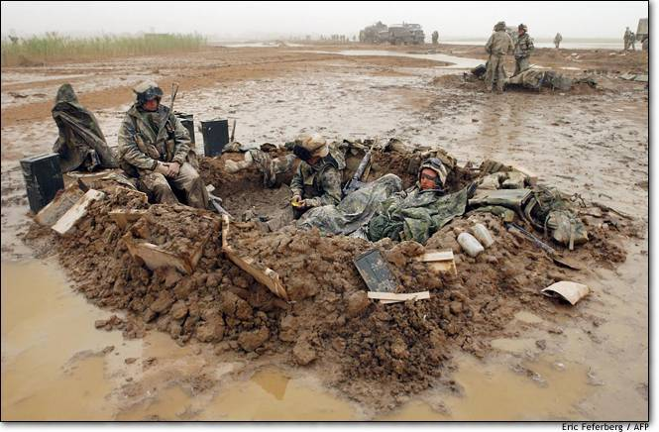

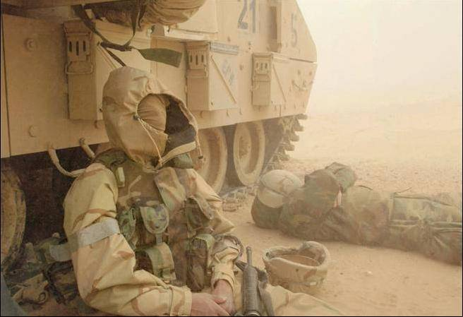


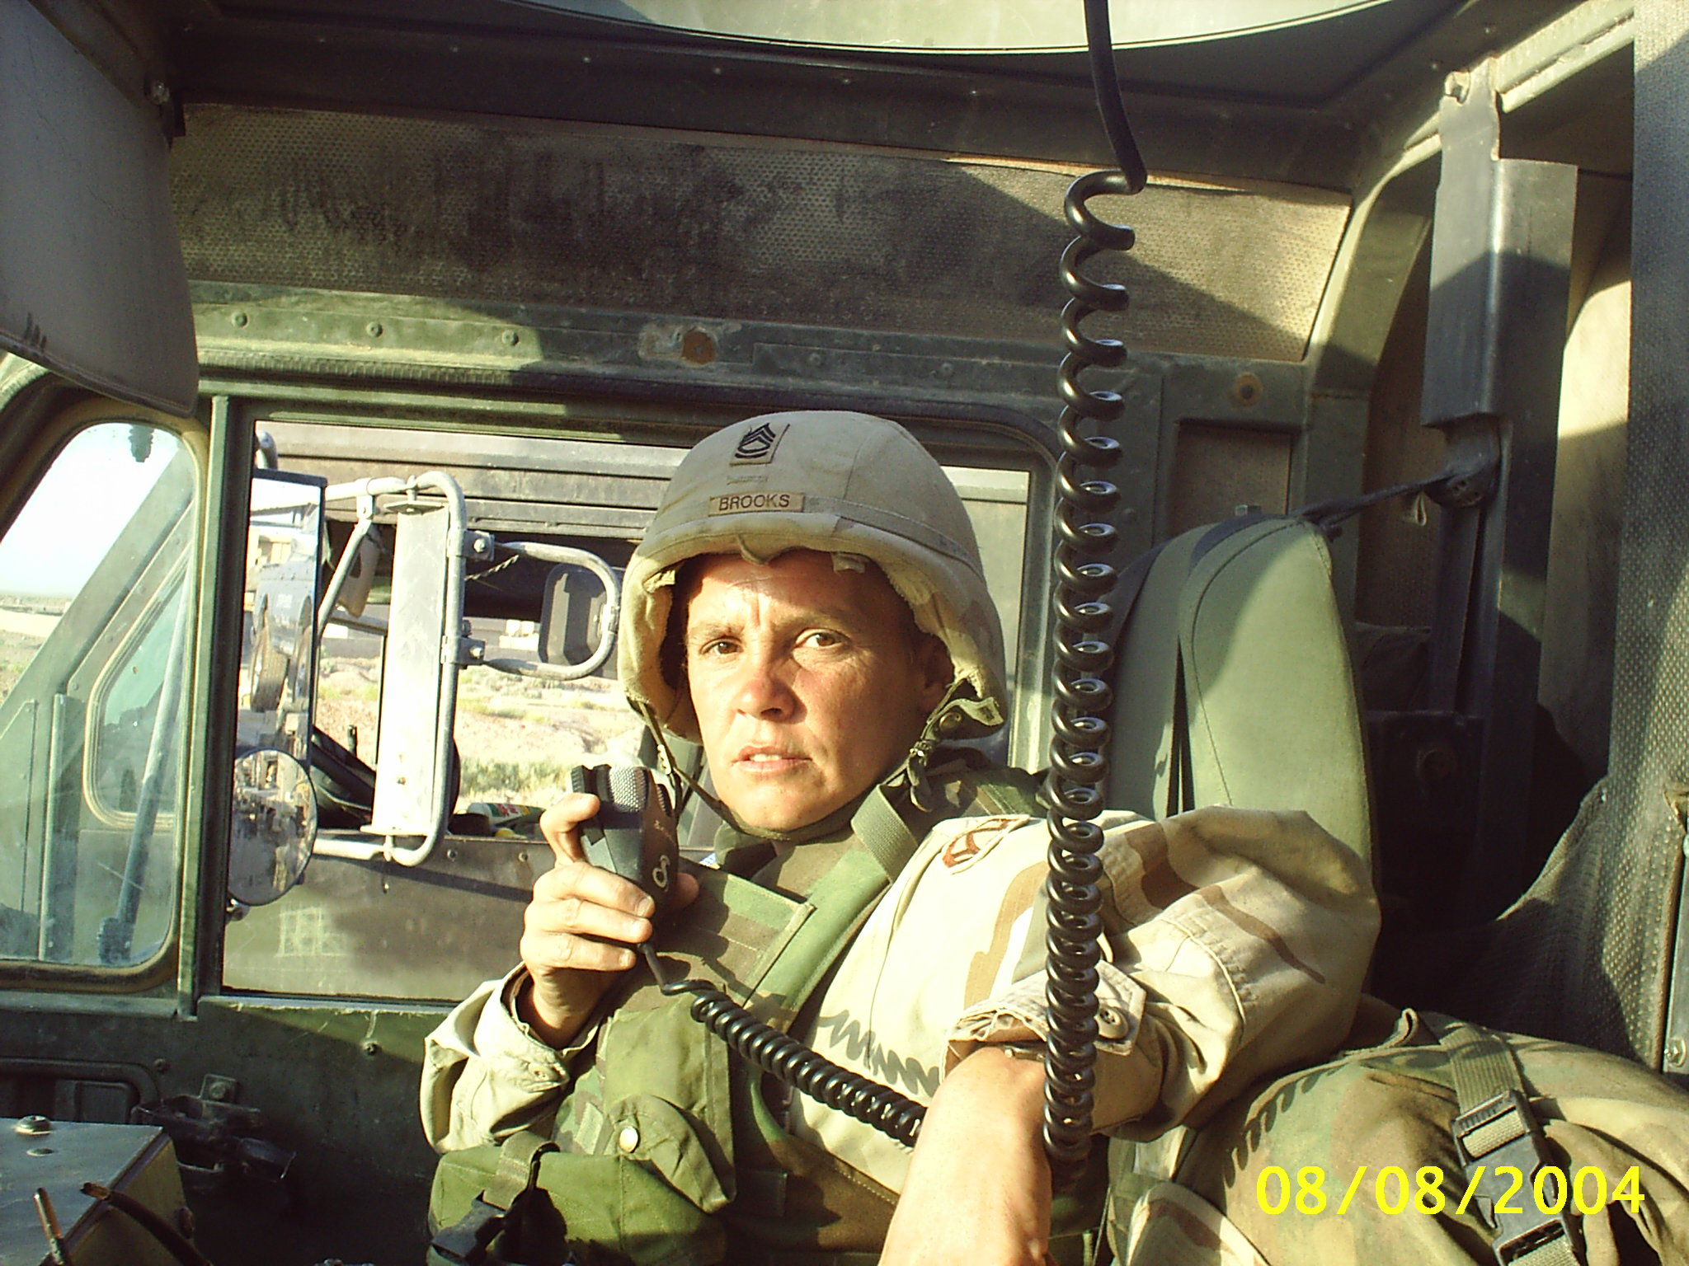

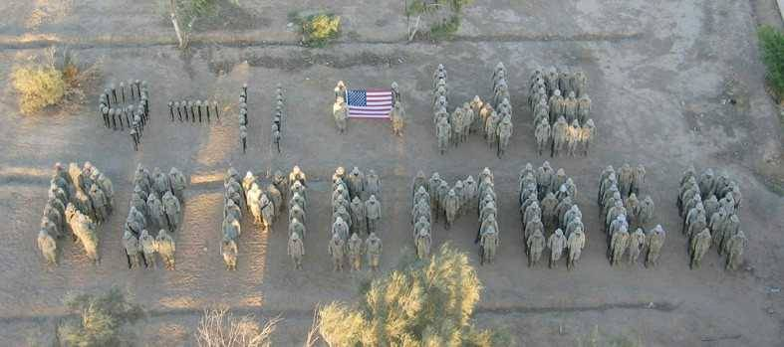
You are cordially invited and encouraged to attend
The River Cities Fiber Guild Annual Christmas Spin

Please join us on December 4, 2004 from 12:00 pm to 4:00 pm at
Good News Llamas in Chesapeake, OH.

There will be food, fun, games, spinning, and baby llama kisses for all!!

Please feel free to bring your wheel, knitting, crochet or other fiber work.

We will have a passing party if you’d like to take part please bring a $5.00 limit-passing gift. Everyone is asked to bring a covered dish. We will take care of paper products, ice, and drinks.

Parking is limited, please car pool if possible!

Please RSVP and list what food you are brining to Judy at ross@musom.edu

Don’t miss out on this wonderful time!

Page 9 of 10
Spinning a yarn

Want to try something fun? Got some yarn you bought and haven’t done anything with? Got some handspun and you aren’t sure what to make from it?

Bring a ball or skein of yarn you have handspun or really like to the guild meeting October 25.

Someone will draw your yarn from a group and make you a scarf! It could be knitted, crocheted, plain or fancy.

The cool thing is you have a great new scarf and some used up stash!

The scarves will be exchanged at the Christmas party. So another bonus an early Christmas present!

Everyone is encouraged to take part even beginner knitters or crocheters!!

We will have several scarf patterns available for you to use at the October Guild meeting!

Events, meetings, classes

River Cities Fiber Clan

October 25 2004 – River Cities Fiber Clan Meeting

November 6 – Field Trip to the Spinning Turtle Yarn Shop – Athens Ohio.

November 6-9 - North American Livestock Expo – Louisville, KY
http://www.livestockexpo.org/index.htm

November 20 – Handspun/Handwoven Show
http://www.geocities.com/wg_mv/haha.htm

November 22 – River Cities Fiber Clan Meeting

December 4 - Christmas Party and Gift exchange at Good News Llamas

113 Nelson Avenue
South Point, Oh 45680

Phone:
(740) 377-9516

(740) 867-4267

E-Mail:
Mitziross1@aol.com

ross@marshall.edu
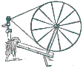

Starting in November…

Monthly Saturday Spin-in

Come out to Yarn and More November 13 for a spinning good time. Bring your wheel, some fiber and spin, spin, spin! See you from 12:00 – 2:00

We’re on the Web!
See us at:
www.goodnewsllamas.com/fiberguild

About Our Organization…
We are guild dedicated to fiber arts. Handspinning, weaving, knitting, crochet, felting and other fiber arts.
We welcome members of all skill levels.
We meet on the Fourth Monday of each month for regular meeting.
Special events and seminars are held on Saturdays.
We meet at First Southern Baptist, 110 Collins Avenue, South Point, OH.
Off 52 by the post office.
Come visit soon!

River Cities Fiber Clan
113 Nelson Ave
South Point, OH 45680

