Judy Ross  Good News Llamas  975 Co. Rd. 104  Chesapeake, OH 45619  740-867- 4267  goodnewsllamas@zoominternet.net  Please visit our website http://goodnewsllamas.com | 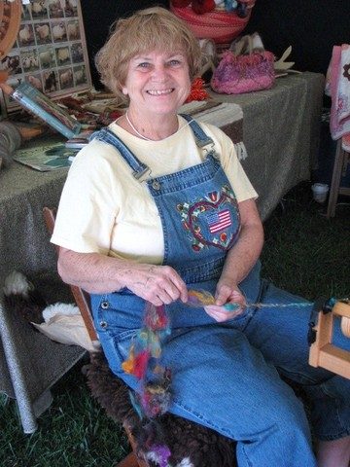

Judy Ross shares a farm with her husband Tom and 26 llamas and two alpacas in Southern Ohio on the West Virginia border. She has been involved with the llama community since 1996. Judy loves llamas and especially llama fiber and has worked hard to develop a herd of fine fiber animals.

She has 12 years experience as an exhibitor of llama shorn fleece, walking fiber/fleece on, and fleece products. Judy strives to learn all she can about fiber, showing fleeces, shearing, and processing fiber. She loves sharing her knowledge.

She also enjoys spinning, crocheting, felting, knitting and using natural dyes for her llama fiber. She is always working on improving her skills and learning new techniques. She regularly attends classes at the John C. Campbell folk school, Cedar Lakes, and other fiber events.

Judy is a certified llama fleece judge for both ALSA and the ILR-SD. She facilitates workshops on working with and preparing llama fleece. She has written several articles on fleece, preparation, showing and other aspects of the fiber industry. Judy also is available for herd evaluations at your farm.

She has worked for several years with llama rescue efforts. She has had several positions in the Ohio River Valley Llama Association, TriState Llama Caregivers and is a current member of the ILR-SD fleece committee.

The Ross’s focus is on public relations, llama education, helping new or potential owners, promoting responsible breeding and responsible selling. They love exposing their community to the joy of owning llamas by working with schools, churches, festivals, parades, and other community events.

