I want to enter a shorn fleece class- Where do I start?
Selecting, Skirting, Showing, Storing
Judy Ross, Good News Llamas
In the beginning, I was one of those exhibitors that had to have the perfect top score of 10 for “cleanliness” fleece. The goal of my entry was to obtain the “blue ribbon”, but as I became more involved and listened to some very wise fleece mentors there is so much more to the final outcome of that fleece before you. As a fleece exhibitor for many years my learning process continues each time the spring shearing begins. That excitement of all the beautiful natural colors and imagining how that fleece can be used to create something beautiful and usable. As a certified llama fleece judge I have had the privilege of examining beautiful lustrous fleeces and this experience has allowed me to re-think my idea of a shorn show fleece.
On our farm, I will start evaluating the llamas before we begin our spring shearing. They enjoy the hands-on and back scratching after a long winter. I like to use a fiber grading worksheet and keep from year to year to see how my fleeces change due to age, weather, stress and nutrition. The health of your fiber can tell a lot about the health of your llama.
You may be asking what is it - fleece or fiber? An easy way to remember is - Fiber is what the llama grows to cover its body. Fleece is what we remove/harvest to process and use.
Here are some things to think about while you are evaluating your herd. This will be part of the judging process for your show fleeces:
- Identify the fleece type, Double, Single, Silky, Suri. Does the fleece have crimp/crinkle?
- Do I have at least 3 to 4 inches of growth (staple length)?
For a show fleece you need at least 3 inches minimum. A maximum staple length for ILR-SD is 6 inches over 13 months and in ALSA 8 inches over 24 months.
- Does the llama have a natural luster (shine)?
- Does the fleece feel healthy and alive, not dry or matted? Is it strong (tensile strength) when you apply pressure? Does it break or have a crackle sound when you pull a lock?
- When you feel the fleece is it appealing (soft) to your touch? Do you have silk or burlap?
Now you are ready to pick a show and enter! Remember we currently have two show associations with fleece shows. Be sure to check the guidelines for details on how to enter your fleece and direct you to the proper entry forms. They also provide detailed descriptions of fleece terms that will help you understand terminology and forms the judges will use in evaluating your fleece; here are the websites for the show divisions - ALSA – http://www.alsashow.net/ and ILR-SD http://www.lamaregistry.com/. It is also important to check your show entry form for special instructions on entering your shorn fleece.
Here are the steps I use for harvesting show fleeces. Before you shear you can take the following steps to ensure your fleece is in good shape and ready to enter in a fleece show.
Brushing and blowing temporarily destroy the lock structure; I will gently blow out and brush my llama (bath if possible) a week before I shear. I DO NOT use grooming products they tend to build up on the fiber, You want the llama to SMELL like a llama!
I use ORVUS shampoo and would also recommend the  Lock N Luster grooming products.  Let your llama drip dry as blowing will mat the fleece when it is wet, you can scrunch it up just as you would curly permed hair, this will also allow air flow to the fleece as it dries. You want the natural lock structure to be restored. | 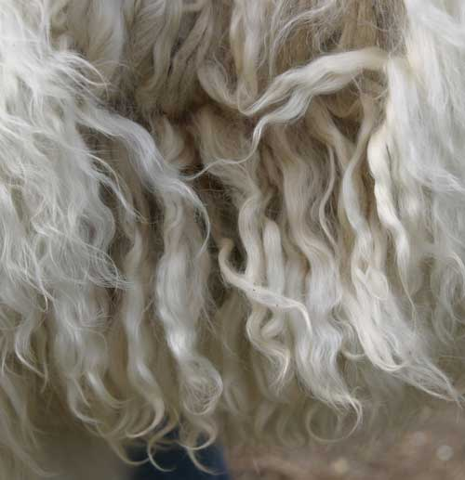
Just before shearing if the llama is really dusty I will GENTLY blow them out with a downward motion. Now only picking the large debris. The judge will be looking for the lock structure to be intact. The less you handle the fleece the more natural look it will have. A little debris is much better that over grooming to have a perfectly clean llama.
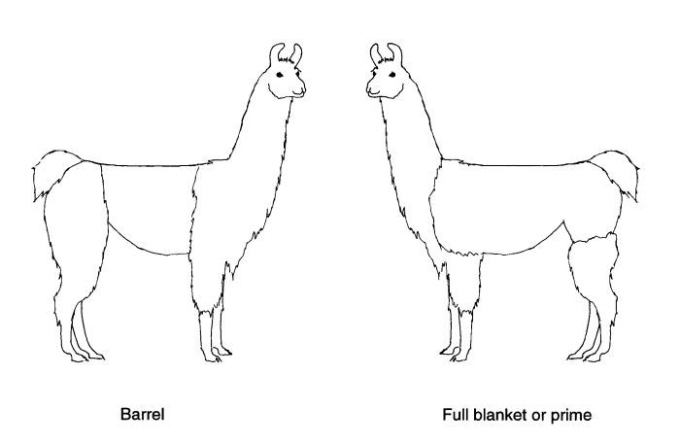 | How you shear can make a big difference in fleece. You want to focus on the prime fleece. That is located on the barrel section of the llama from the shoulder to hip area for a full blanket.
The ILR-SD uses annualized weight as part of the scoring process and some exhibitors are selecting the full blanket cut to harvest the entire prime fleece. If you plan to enter your llama in the fleece-on/walking fiber classes the full blanket will not be your best choice since it leaves almost no prime fleece to evaluate on the animal.
While you are shearing your animal, be aware of your clipper oil, this can leave an unwanted odor and residue on your fleece. You will also want to watch for second cuts, areas of short hair where you reclipped or recut the fleece.
On our farm my husband does the shearing with electric shears. It is up to your preference on the use of electric or hand shears. As he shears, I continually say “no second cuts”. To make things easier during shearing I put my skirting table up in the barn to receive the fleece as it is removed. I will take each section as it comes off and place it on a skirting table. As I place the fleece cut side down on the table, I gently shake the fleece to remove the dust and second cuts before they can attach to the locks. This helps a great deal in the next processing – skirting. As you shear, remove the topline, and belly hair. This is not considered prime fleece and should not be part of your show fleece. You can place them in a separate container for felting or other uses. I place the fleece in a clothes basket until I am ready to fully skirt.
The next part of the process is skirting. Skirting is the removal of the undesirable part of the fleece – belly hair, second cuts, sticks, etc. You may be asking why do I need to skirt a fleece? It allows you to present a prime clean fleece for judging. I have found that a fleece will skirt easier right after shearing, the longer it sets the more difficult is it to skirt as the fibers will begin to mesh/felt together. Just remove what you don’t want!
Lay your fleece out on a skirting table, old piece of screen or any flat surface. A fleece may contain second cuts (tiny pieces at the end of the cut end of the lock), urine stains, mats, course belly fibers, hay and other vegetable matter. The skirting will produce a cleaner fleece for showing and a more usable end product. A clean fleece will save on shipping and processing costs if you send your fleece to a mill.
After your show fleece has been selected and skirted it is placed in a large plastic laundry basket with holes to allow air flow, placed in an area in an unused room that will be free from unwanted odors and left alone.
At the show you will be judged against a particular group of fleeces entered in the show. The judge will use a score card to evaluate your fleece and may make comments for improvement or things that need your attention on the score card. Hopefully you will see your prize fleece display with a ribbon!
There are many elements that can affect your fleece – shipping, examination by the judge, handling by inexperienced show clerks, weather elements and storing. Here are tips and tricks to help you keep your show fleece in top condition.
To ensure your fleece remains in the best condition for showing, remember when storing your fleece it needs to breathe and not be constricted. Think about what ages your show fleece – over handling, smashing it into a bag, keeping it in a damp area – avoid these to keep your fleece in good shape.
Most shows will allow you to ship your fleece for showing. Even though some judges do not like to see a fleece wrapped in tissue paper, I use this method when shipping. I have found from experience that it keeps my fleece from shifting around and has eliminated the static for me. When removed from the shipping container the clerk can easily unroll and it is still in one piece and can place in the CLEAR plastic bag I have included along with my paperwork for entry. I have the postal service put “fragile” handle with care on the box as well as an enclosed note to please handle with care. One thing to remember is you cannot expect the show clerk or superintendant to re-pack your fleece just as you sent it.
Once you bring your fleece back from a show, you will need to check it and make sure everything is ok. I will un-pack my fleece as soon as it is received from the show and if time and weather permits I will put the fleece back on my skirting table gently shake it out a little and allow it to lay and have time to breathe and to restore the lock structure. I now will store my fleece in the same laundry basket or a plastic container that is large enough to allow the fleece to be spread out. The process will be repeated each time the fleece is shown. I have had success in showing that fleece three to four times during the year.
The good thing about showing your fleece is that at the end of the show season you can think about what you will make from your fleece. Be creative and enjoy!

