SHORN FLEECE VERSUS FLEECE ON/COAT ON
Understanding Each Division
by: Mary Jo Miller

Exhibiting llama fleece is one of the most rewarding and easy ways to showcase your llamas and farm.
The Shorn Fleece division is for showing the prime fleece shorn off of the llama. The Fleece On/Coat On division is for showing the prime fleece while it is still on the llama.
Shorn fleece classes are the venue to truly get the maximum evaluation of your llama’s fleeces. Why is that? Because you start out with the entire prime area of your llama and have the opportunity to skirt out any portions which are of a lower quality as well as eliminate any debris. On top of that, you don’t actually have to attend a show to exhibit the fleece. An East Coast fleece can easily exhibit in a West Coast show by mailing their entry, and vice versa! An exhibitor can literally show at any show across the country by mailing their entry. The down side of shorn fleece competition is that continuous handling, mailing and exhibiting do have its limitations to keep the integrity of the fleece. i.e. Shorn fleece does have a limited “show life”.
On the other hand, Fleece On/Coat On competition was developed to encourage exhibitors to show their llama’s prime fleece on the animal. Folks need to understand that the Fleece On/Coat On division wasn't created to be the "end all" judging of fleece. That's what the shorn class represents. Shorn Fleece classes are the ultimate evaluation of your fleece. The Fleece On/Coat On class was developed to get folks excited about fleece, educate folks on fleece, and to just plain give exhibitors another spot to exhibit and show off their llamas, allowing them to gain additional credentials for their llamas. It was never meant to replace or be an equal evaluation of fleece that we get with the shorn classes.
ILR-SD has also developed the Composite class which is the combination of a llama’s halter and Fleece On/Coat On placings.
This brings us to the question, to compete in Fleece On/Coat On – should I shear or not shear? And if I shear – do I leave a swatch (patch) on one or both sides of my llama’s prime fleece on the barrel?
Let me stress, ILR-SD’s first concern is the health of the animal which means we encourage shearing. We (ILR-SD) cannot dictate how an animal is shorn. This is an owners/breeder’s choice.
First - let’s realize that the only scores affected by shearing with or without a swatch, are the Uniformity of Length which has a total of 5 points and Uniformity of Lock Formation which is another total possible of 5 points. It is very rare to give a perfect score of 5. If the llama is totally naked (body) shorn, it would still receive a score of 1. Most scores are only going to fall right in the middle with an average score, so we are talking about a variation of 3 points in two of the Uniformity categories.
We are talking about a possible variation of 3 points in two of the Uniformity categories.
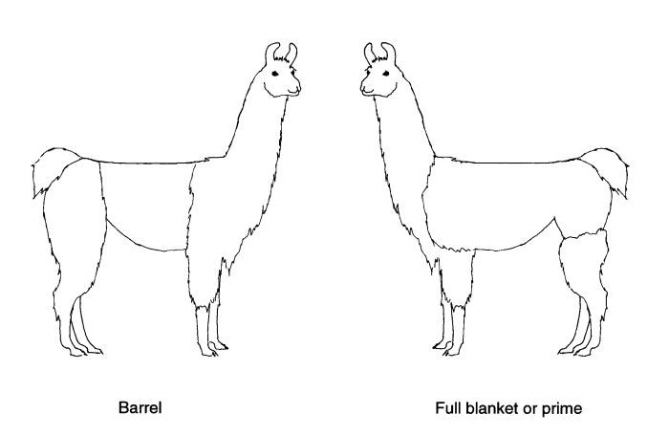
Leaving a swatch for Fleece On/Coat On competition is totally up to the exhibitor/breeder. If the swatch is within minimum/maximum length and isn't groomed, it will only confirm or debate what the judge has found in the llama's fleece in other parts of the prime. That is, considering there is sufficient shoulder and rump fleece left on the shorn llama to make a comparison. If confirmed, it should strengthen the score. Would the llama with the swatch get the same score as a fully fleeced llama-(considering everything about the two fleeces were identical)? – No- because we as judges could only confirm what we are seeing and feeling in one additional small spot of the shorn prime on the animal with the swatch, as shearing eliminates a great deal of the prime fleece. The fully fleeced llama would have fleece in every area of the prime to evaluate. Would leaving on a swatch guarantee a higher score? – No as again it isn’t the entire prime area only a portion of the prime. Many farms only shear barrels, which can allow more prime (on the hip and or shoulder) to be examined in Fleece On/Coat On.
Remember, the judge in Fleece On/Coat On competition examines the entire prime area of the llama being judged-whether the llama is full fleeced or shorn (with or without a swatch). If shearing your llama, it is suggested that you leave as much prime fleece as possible on the shoulder and hip.
There is concern that leaving a swatch on the side of a llama hurts the animal in a halter class. The presence of a swatch shouldn’t have any affect on a halter class as the “look of a swatch” doesn't have one thing to do with conformation. For this reason, it shouldn't hurt to leave a swatch for halter competition. Some folks don’t like the “looks” of the swatch-but again-that doesn’t have anything to do with conformation. Considering 10% of halter judging is fleece (fineness, hand and luster), a swatch or fleece left unshorn on the shoulder and or hip could help a halter judge debating between two llamas and using the 10% as a tie breaker. The “look” of a swatch shouldn’t have any bearing on a halter placing however.
If all owners/breeders at the show shear their animals, all animals will be at the same disadvantage/advantage. But remember – we are only talking about a possible 3 point difference of points in two of the Uniformity categories.
It is suggested, if you choose to leave a swatch, make sure it is healthy and the condition is not cotted nor has the lock structure been groomed out. The ILR-SD will not set a standard that swatches need to be present to receive the highest possible score on shorn llamas.
Let me repeat - Fleece On/Coat On competition was developed to encourage more folks to show off their llamas fleece, educate llama owners on the value of their animal's fleece and give them another class in which to show. It was never intended to encourage folks not to shear their animals. It is a breeders choice to shear and if shorn to leave one or more swatches. And we encourage you to submit the shorn fleece for competition in shorn fleece class.

